**Java Script lab Exercises-1**

* Define a function max() that takes two numbers as arguments and returns the largest of them. Use the if-then-else construct available in Javascript.

function max(a, b) {

if (a > b) return a;

else return b;

}

console.log(max(5, 9));

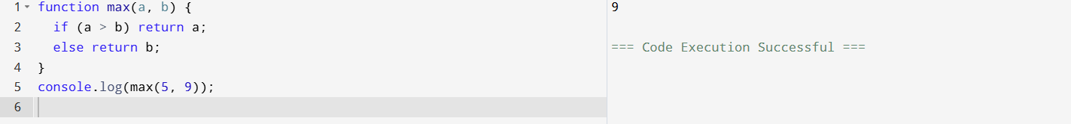

* Define a function maxOfThree() that takes three numbers as arguments and returns the largest of them.

function maxOfThree(a, b, c) {

if (a >= b && a >= c) return a;

else if (b >= a && b >= c) return b;

else return c;

}

console.log(maxOfThree(3, 7, 5));

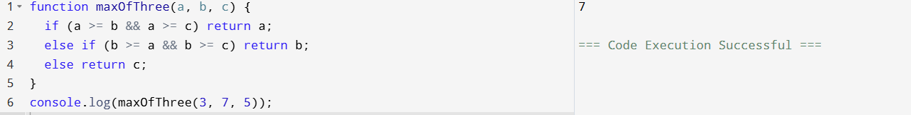

* Write a function that takes a character (i.e. a string of length 1) and returns true if it is a vowel, false otherwise.

function isVowel(ch) {

return ['a','e','i','o','u','A','E','I','O','U'].includes(ch);

}

console.log(isVowel('a'));

console.log(isVowel('b'));



* Write a function translate() that will translate a text into "rövarspråket". That is, double every consonant and place an occurrence of "o" in between. For example, translate("this is fun") should return the string "tothohisos isos fofunon".

function translate(text) {

let result = '';

for (let ch of text) {

if ('bcdfghjklmnpqrstvwxyz'.includes(ch.toLowerCase())) {

result += ch + 'o' + ch;

} else {

result += ch;

}

}

return result;

}

console.log(translate("this is fun"));

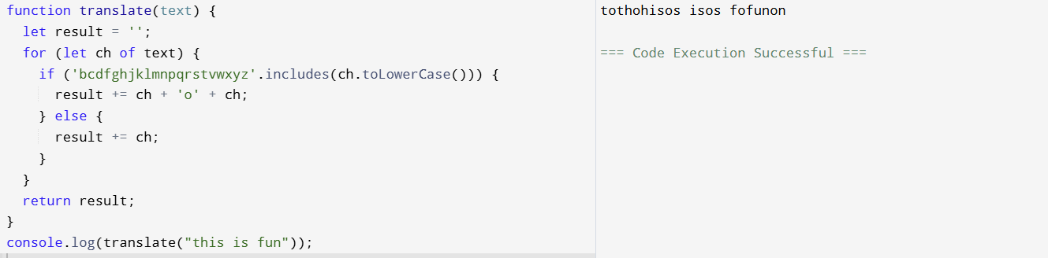

* Define a function sum() and a function multiply() that sums and multiplies (respectively) all the numbers in an array of numbers. For example, sum([1,2,3,4]) should return 10, and multiply([1,2,3,4]) should return 24.

function sum(arr) {

return arr.reduce((a, b) => a + b, 0);

}

function multiply(arr) {

return arr.reduce((a, b) => a * b, 1);

}

console.log(multiply([1,2,3,4]));

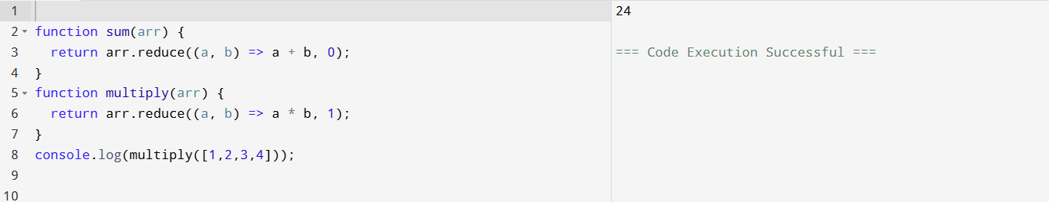

* Define a function reverse() that computes the reversal of a string. For example, reverse("jag testar") should return the string "ratset gaj".

function reverse(str) {

return str.split('').reverse().join('');

}

console.log(reverse("jag testar"));

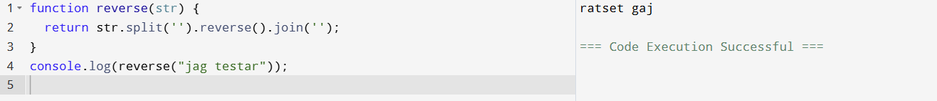

* Represent a small bilingual lexicon as a Javascript object in the following fashion {"merry":"god", "christmas":"jul", "and":"och", "happy":gott", "new":"nytt", "year":"år"} and use it to translate your Christmas cards from English into Swedish.

let lexicon = {

"merry":"god", "christmas":"jul", "and":"och",

"happy":"gott", "new":"nytt", "year":"år"

};

function translateToSwedish(text) {

return text.split(" ")

.map(word => lexicon[word.toLowerCase()] || word)

.join(" ");

}

console.log(translateToSwedish("merry christmas and happy new year"));

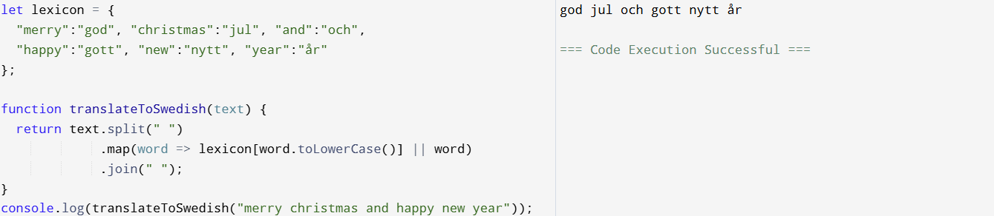

* Write a function findLongestWord() that takes an array of words and returns the length of the longest one.

function findLongestWord(words) {

return Math.max(...words.map(w => w.length));

}

console.log(findLongestWord(["apple","banana","cherry","pineapple"]));

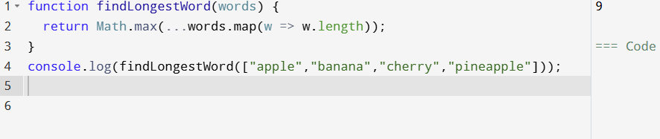

* Write a function filterLongWords() that takes an array of words and an integer i and returns the array of words that are longer than i.

function filterLongWords(words, i) {

return words.filter(w => w.length > i);

}

console.log(filterLongWords(["hi","hello","wonderful"], 4));

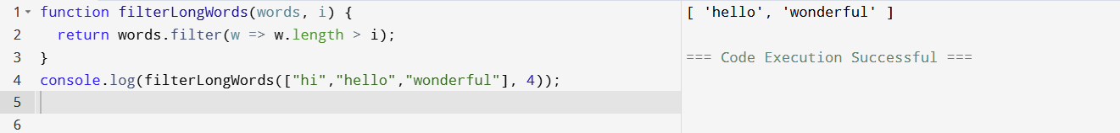

* Write a function charFreq() that takes a string and builds a frequency listing of the characters contained in it. Represent the frequency listing as a Javascript object. Try it with something like charFreq("abbabcbdbabdbdbabababcbcbab").

function charFreq(str) {

let freq = {};

for (let ch of str) {

freq[ch] = (freq[ch] || 0) + 1;

}

return freq;

}

console.log(charFreq("abbabcbdbabdbdbabababcbcbab"));

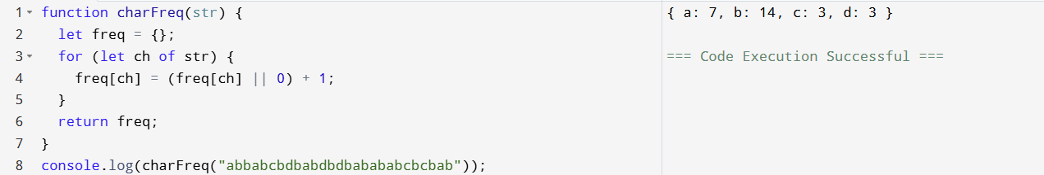

* Design a calculator using java script.

<!DOCTYPE html>

<html>

<body>

<h3>Simple Calculator</h3>

<input id="num1" type="number">

<select id="op">

<option>+</option>

<option>-</option>

<option>*</option>

<option>/</option>

</select>

<input id="num2" type="number">

<button onclick="calculate()">=</button>

<span id="result"></span>

<script>

function calculate() {

let n1 = parseFloat(document.getElementById('num1').value);

let n2 = parseFloat(document.getElementById('num2').value);

let op = document.getElementById('op').value;

let result;

switch(op) {

case '+': result = n1 + n2; break;

case '-': result = n1 - n2; break;

case '*': result = n1 * n2; break;

case '/': result = n1 / n2; break;

}

document.getElementById('result').textContent = result;

}

</script>

</body>

</html>

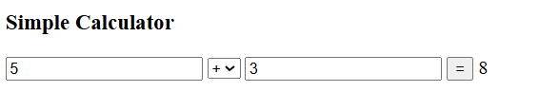

* Write a script that asks the user for a series of names until the user hits the cancel button. The script then sorts the names in alphabetical order and prints the names in an ordered list.

<script>

let names = [];

while (true) {

let name = prompt("Enter a name (Cancel to stop):");

if (name === null) break;

names.push(name);

}

names.sort();

document.write("<ol>");

for (let n of names) document.write("<li>" + n + "</li>");

document.write("</ol>");

</script>

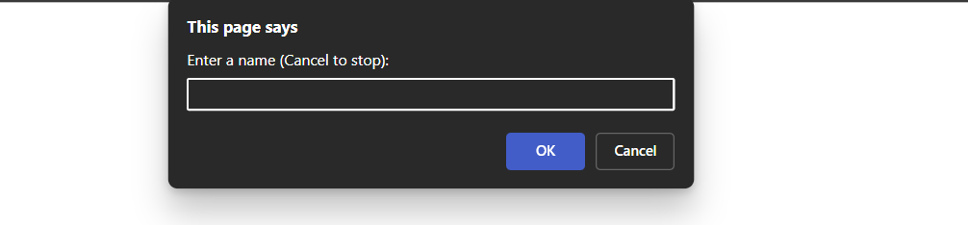

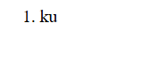

* Write a script that asks the user how many random numbers they wish to generate. The script then generates the numbers and calculates the average of the numbers and returns the results to the user.

<script>

let count = parseInt(prompt("How many random numbers to generate?"));

let numbers = [];

for (let i = 0; i < count; i++) {

numbers.push(Math.floor(Math.random() * 100) + 1);

}

let avg = numbers.reduce((a,b)=>a+b,0) / count;

alert("Numbers: " + numbers.join(", ") + "\nAverage: " + avg);

</script>

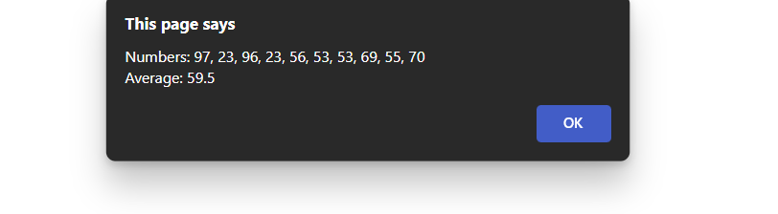

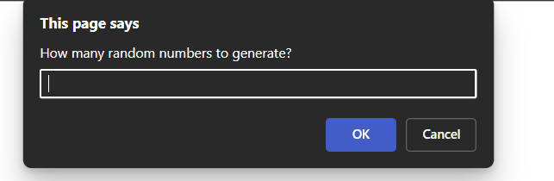

* Create registration form webpage for your site with the following form fields - Name, User name, password and confirm password (both must be the same), year of birth and email, a checkbox for the use to select that he/she agree to the terms and conditions of the website.  
  Validations to do on this page:
* check if both the passwords are the same.
* check if user name, password, confirm password, email are not empty and checkbox is selected.
* Password and confirm password are the same.
* Email is in the correct format.
* Year of birth should be between 1900 and 2000 and must be four digits only.

<!DOCTYPE html>

<html>

<body>

<form onsubmit="return validateForm()">

Name: <input id="name"><br>

Username: <input id="username"><br>

Password: <input id="password" type="password"><br>

Confirm Password: <input id="confirm" type="password"><br>

Year of Birth: <input id="yob"><br>

Email: <input id="email" type="email"><br>

<input id="terms" type="checkbox"> I agree to the terms<br>

<button type="submit">Register</button>

</form>

<script>

function validateForm() {

let username = document.getElementById('username').value;

let password = document.getElementById('password').value;

let confirm = document.getElementById('confirm').value;

let yob = document.getElementById('yob').value;

let email = document.getElementById('email').value;

let terms = document.getElementById('terms').checked;

if (!username || !password || !confirm || !email) {

alert("Please fill all fields!");

return false;

}

if (password !== confirm) {

alert("Passwords do not match!");

return false;

}

if (!terms) {

alert("You must agree to terms!");

return false;

}

if (!/^\d{4}$/.test(yob) || yob < 1900 || yob > 2000) {

alert("Year of birth must be 4 digits between 1900 and 2000!");

return false;

}

return true;

}

</script>

</body>

</html>

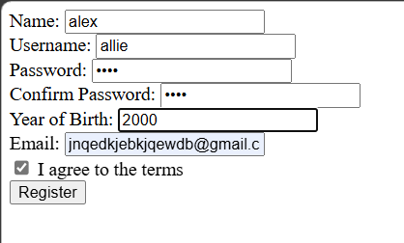

* Write the XHTML tag and event handler to pop up an alert message that says "Welcome" when the user clicks a button.

<!DOCTYPE html PUBLIC "-//W3C//DTD XHTML 1.0 Strict//EN"

"http://www.w3.org/TR/xhtml1/DTD/xhtml1-strict.dtd">

<html xmlns="http://www.w3.org/1999/xhtml">

<head>

<title>Welcome Button</title>

<script type="text/javascript">

function showWelcome() {

alert("Welcome");

}

</script>

</head>

<body>

<input type="button" value="Click Me" onclick="showWelcome();" />

</body>

</html>

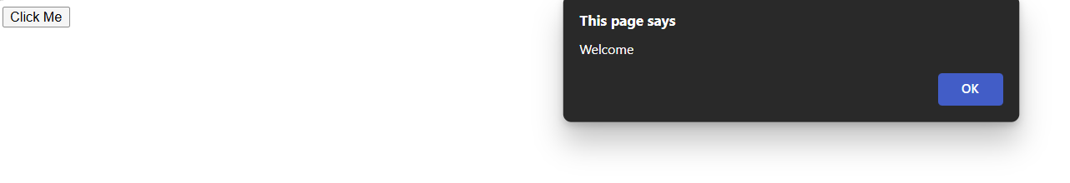

* Write the XHTML tag and event handler to pop up an alert message that says "Welcome" when the user moves the mouse pointer over a link that says "Hover for a welcome message".

<!DOCTYPE html PUBLIC "-//W3C//DTD XHTML 1.0 Strict//EN"

"http://www.w3.org/TR/xhtml1/DTD/xhtml1-strict.dtd">

<html xmlns="http://www.w3.org/1999/xhtml">

<head>

<title>Hover Welcome</title>

<script type="text/javascript">

function hoverWelcome() {

alert("Welcome");

}

</script>

</head>

<body>

<a href="#" onmouseover="hoverWelcome();">Hover for a welcome message</a>

</body>

</html>

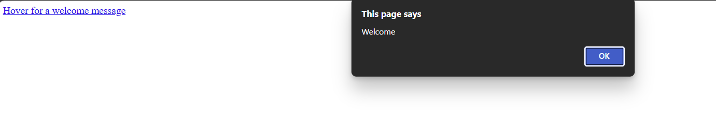

* Create a form that asks the user to enter their name, age, and hometown. When the user presses the Submit button, call a JavaScript function. The JavaScript function should perform the following actions:
* display the user's name and year they were born (depending on actual date of birth) on the webpage below the form.
* display a link to Google (or Bing) search results for the name of their hometown.

<!DOCTYPE html>

<html>

<head>

<title>User Info Form</title>

</head>

<body>

<form onsubmit="return displayInfo();">

Name: <input id="name" type="text" /><br />

Age: <input id="age" type="number" /><br />

Hometown: <input id="town" type="text" /><br />

<input type="submit" value="Submit" />

</form>

<div id="output"></div>

<script type="text/javascript">

function displayInfo() {

var name = document.getElementById("name").value;

var age = parseInt(document.getElementById("age").value);

var town = document.getElementById("town").value;

var currentYear = new Date().getFullYear();

var yearBorn = currentYear - age;

var output = "<p><strong>" + name + "</strong> was born in " + yearBorn + ".</p>";

output += '<p><a href="https://www.google.com/search?q=' + encodeURIComponent(town) + '" target="_blank">Search for ' + town + ' on Google</a></p>';

document.getElementById("output").innerHTML = output;

return false; // prevent form submission (page reload)

}

</script>

</body>

</html>

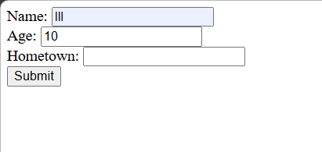

* Use JavaScript to create a rollover image. Choose two images with the same size. Display one image. When the mouse passes over the image, change it to the second image. When the mouse leaves the image, change back to the original image.

<!DOCTYPE html>

<html>

<head>

<title>Rollover Image Example (Web Images)</title>

</head>

<body>

<img id="myImage"

src="https://www.balisafarimarinepark.com/wp-content/uploads/2022/04/13_Camel-1-1200x1200-cropped.jpg"

onmouseover="https://img.jagranjosh.com/images/2022/November/28112022/camel-flu.jpg';"

onmouseout=" onmouseout="this.src='https://upload.wikimedia.org/wikipedia/commons/thumb/6/6a/JavaScript-logo.png/240px-JavaScript-logo.png';"

alt="Rollover Example"

width="200">

</body>

</html>